Getting to Christianiakirken

The church is located at the back of a large yellow building called ‘Operaen’ on Pusher Street in the Christiania free town (see aerial photo on the next page).

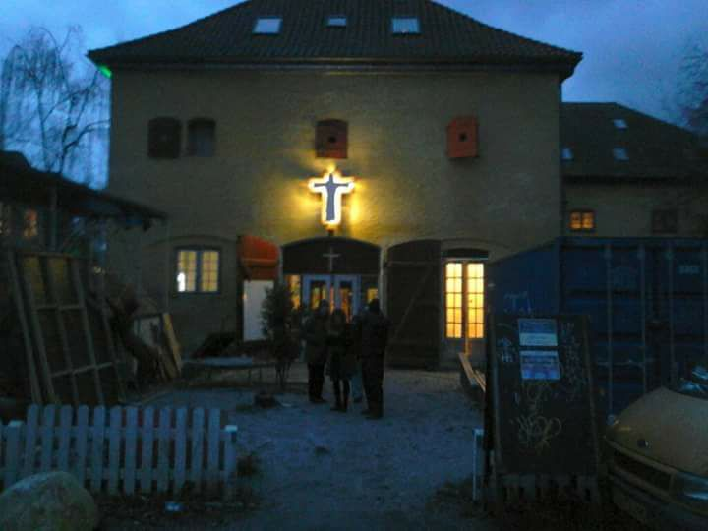

Look out for the resurrected Jesus!

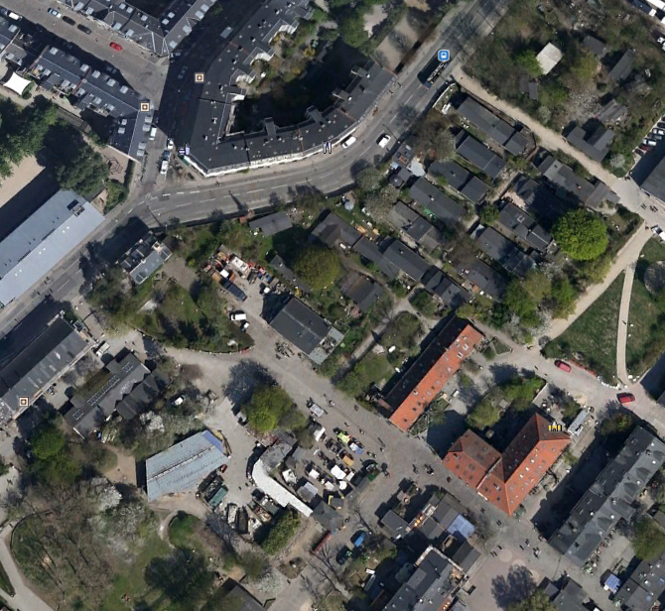

Entrance from Prinsessegade Pusher street church entrance

Christiania Church

